**Gym:** Emerald City, Monroe, WA (12/6/16)

**Trainer:**  Caitlyn

**Fitness Plan**

**Prev (2014):** 183.0 lbs (10%) 164.7 lbs / 18.3 lbs

**Start (10/16):** 186.6 lbs (16.4%) 156.0 lbs / 30.6 lbs

**Today (11/27):** 181.6 lbs (15.4%) 153.6 lbs / 28.0 lbs

**Goal:** 180.0 lbs (8.0%) 165.6 lbs / 14.4 lbs

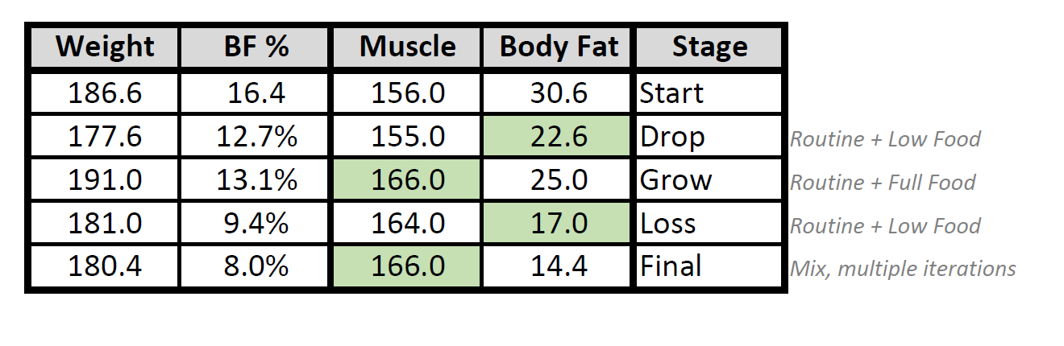 **+10 lbs / -16 lbs**

**Time Target:** 1 year

Start: 11/10/16

Complete: 11/10/17

**Activity Keypoints**

* plan – build up a routine that is pointed towards longer term and establishment of habit
  + You can do extra if desired, no problem (e.g. 6 days per week)
  + Typical high-endurance routine is 4-5 days/wk
* target - 300 minutes over 4 days/wk
* The average healthy weight loss pace is 1 lbs/month

**Note:**

Consider supplementing your diet with a Probiotic and an Amino Acid

* + Your plan calls for at least one year
* Gain muscle first, don’t emphasize weight loss until after
  + “*Convert your weight, it’s not a Lose/Grow game you see*”
  + This minimizes number of cycles and time taken dramatically
  + There will be several rounds to final achieved goals
* Diet and diet-balance are one of the most important long term components of your plan.
  + A primary goal is healthy lifestyle balance, ensure you target something that you can maintain

**Supplemental Nutrients Plan**

Protein (after workout) – 1 Scoops w/Almond Milk

Vega One (lunch replace) – 2 Scoops w/Almond Milk

Aminos (after workout) – 1 Scoop

Water (daily) – 70 oz.

**Routine Plan**

Justin will purse the 3-day lift with 1-day rest until habit and routine is established, at which point he will revisit with Caitlyn to proceed further.

**Fitness History**

**Prev:** 5-6 days/wk lifting

5-6 days/wk treadmill

2-4 days/wk basketball (1hr)

**Now:** 2-4 days/wk treadmill (5mph max)

**Goal:** 4-6 days/wk lifting (45m target)

4-6 days/wk treadmill (10m warm-up, 30m post-workout) (8mph max, 7mph 10m min)

**Starting Plan – Establishing Routine**



**Present Nutrition Plan**





**Nutrition Plan Idea (Upcoming)**





**Fitness Log**





**Nutrition Log**





